How to Setup Proxmox

Hi Everyone, I’m Raf and today’s guide will be on how to setup Proxmox.

Overview:

1. What is Proxmox
2. Tools Needed to Install Proxmox
3. How to Install Proxmox
   1. Run ISO File
   2. Setup Proxmox
   3. Post Setup Things

Download Links:

Proxmox Download Page: [Get the free Proxmox VE ISO installer](https://www.proxmox.com/en/downloads/category/iso-images-pve) ( Select the Latest Version )

Etcher: [balenaEtcher - Flash OS images to SD cards & USB drives](https://www.balena.io/etcher/)

What is Proxmox

Proxmox is a Type 1 Hypervisor, which is basically an operating system made specifically for creating and managing VM’s.

Tools Needed to Install Proxmox

To Install Proxmox we need three tools:

1. Proxmox’s ISO File  
 This is the Installation File for Proxmox

2. Etcher  
 We need a software to burn the ISO file to a USB Drive so for that purpose, we are going to use Etcher.

3. USB Drive  
 We will plug in the USB Drive to the Computer so we can Install Proxmox.

So Download the Proxmox ISO File and use Etcher to burn it onto a USB Drive. Now your USB Drive is ready to use!

How to Install Proxmox

1. Run ISO File

Connect the USB Drive to the Computer and then, turn it on and go to the bios screen. From there find the option to choose to boot drive and select the USB Dive.

2. Setup Proxmox

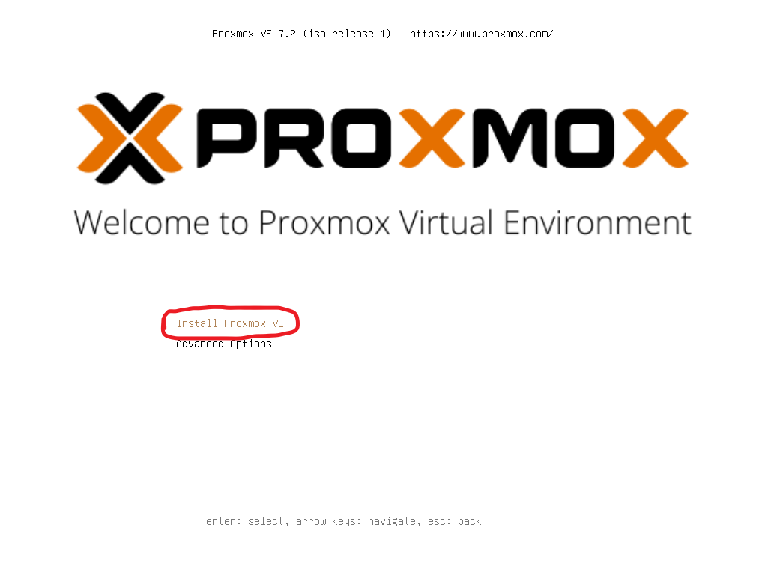

Select the “Install Proxmox VE” Option.

End User License Agreement (EULA)  
 Click “I agree”

Hard Disk  
 Select the Hard Disk you want Proxmox Installed on.

Location and Time Zone selection  
 Choose your Country, Time Zone and Keyboard Layout.

Administration Password and Email Address  
 Enter a Password ( this will be your root user password ) and Email ( If you don’t want to enter an email then just put [mail@example.com](http://mail@example.com) )

Management Network Configuration  
 Management Interface   
 This is your network card, if you have more than one option then choose the one that is faster and the one that is connected to the Internet.   
 Hostname (FQDN)   
 This can be pve.home-network.io.

IP Address (CIDR)  
 This is the IP Address of Proxmox. Note the Current IP Address for later, as we are going to make it a Static IP from the router interface.

Gateway   
 This is the Router IP.

DNS Server  
 You can set this to your Router IP or a DNS IP like for example 8.8.8.8 (Google) or 1.1.1.1 (Cloudflare).

Now Click on “Install”

3. Post Setup Things

Go to the Proxmox dashboard, [https://your_proxmox_ip](http://proxmox_ip):8006

Update Proxmox:

Select pve and select updates  
 Click “Refresh” and once it is done then Click “Upgrade” and press enter  
 Reboot

Proxmox Post Install

Go to <https://tteck.github.io/Proxmox/> and choose the Proxmox VE 7 Post Install and follow the instructions from there.

If you want Dark Mode then on <https://tteck.github.io/Proxmox/> choose the Proxmox Dark Theme and follow it’s Instructions.

And That’s It, now you have Proxmox set up and running!